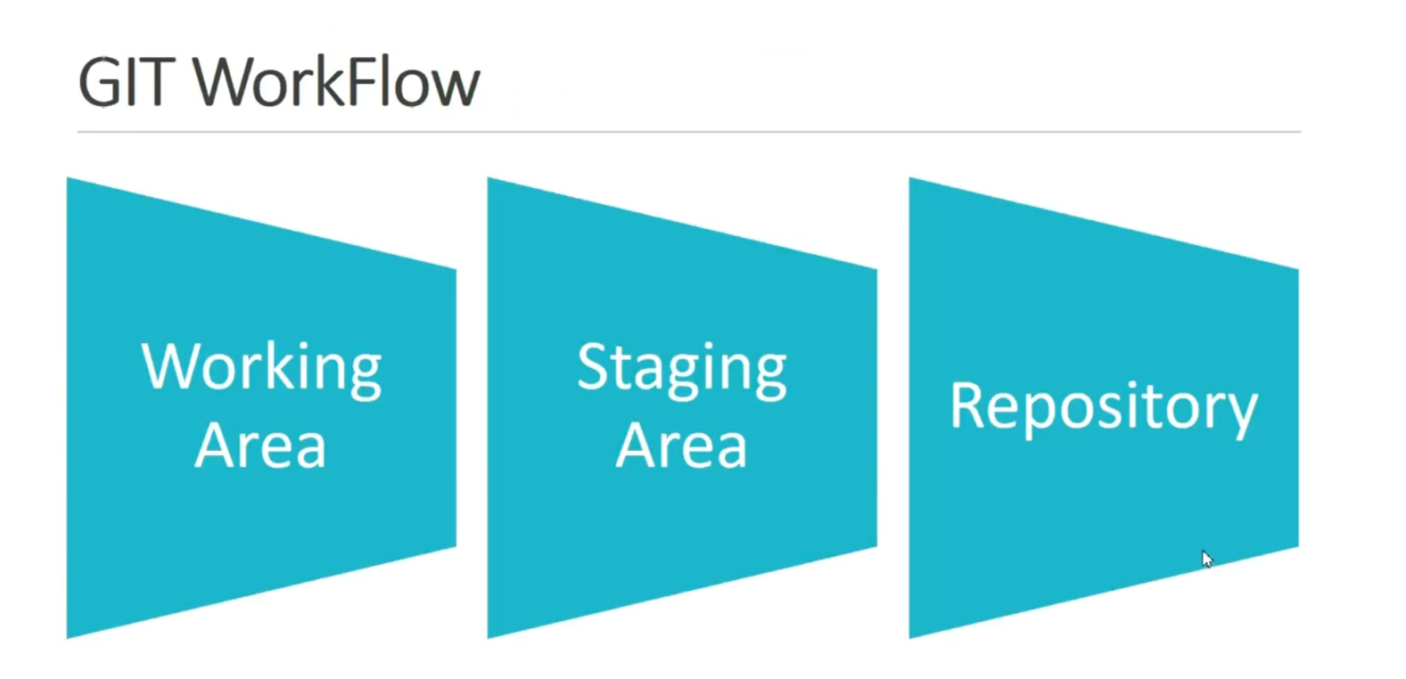

We have three stages in git

1. Working Area
2. Staging Area
3. Repository

Presently got your Git repository directory and modify some of the files

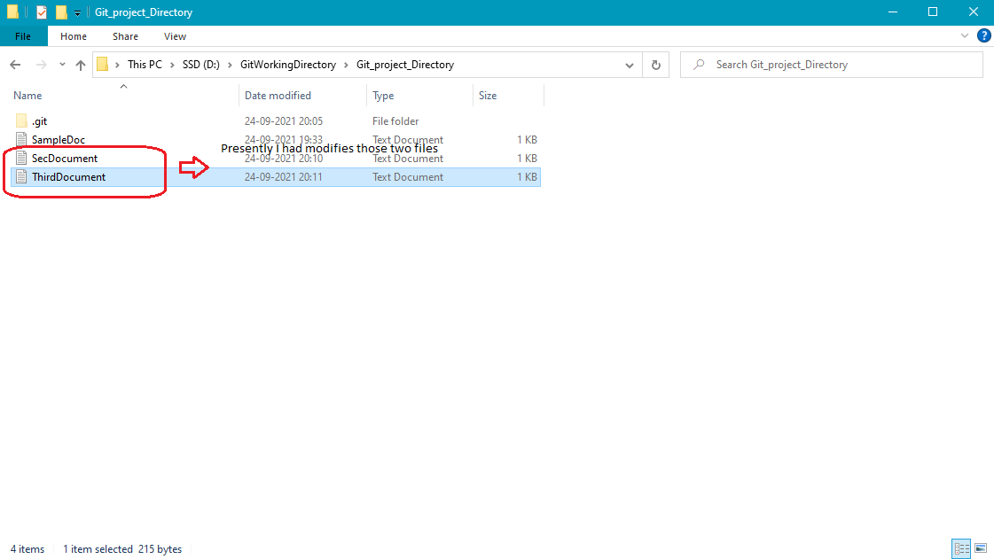

Presently before adding or commiting the files those area is called working Area, also called as Local copy

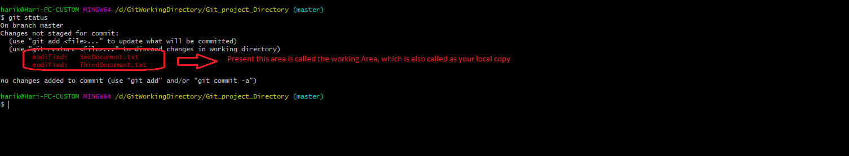

Now as you see above those modified files are in working area, in order to move to staging area you need to add those files by using the command git add.

Now let’s add one file from that and check the status again.

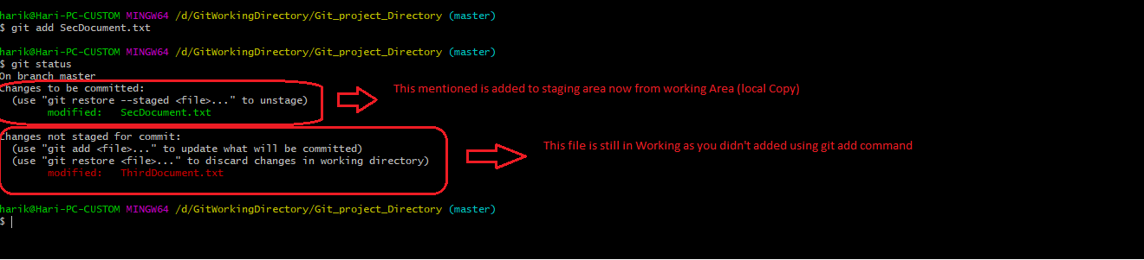

Now let’s modify the file “SecDocument.txt” and see what will happen.

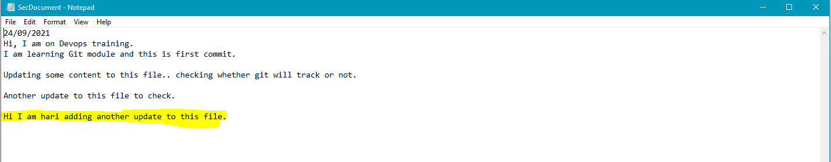

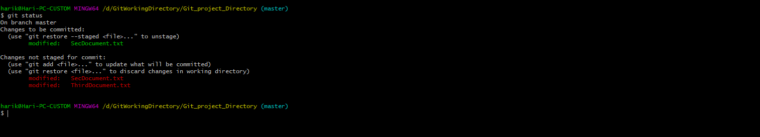

When you check status git status now, it will show the same file in both areas one is on Staging Area which is ready to commit and another on local working Area which are untracked changes to add to that file.

Now if I commit to the copy to Git it will only commit the copy which are in Staging area not the copy of working Area.



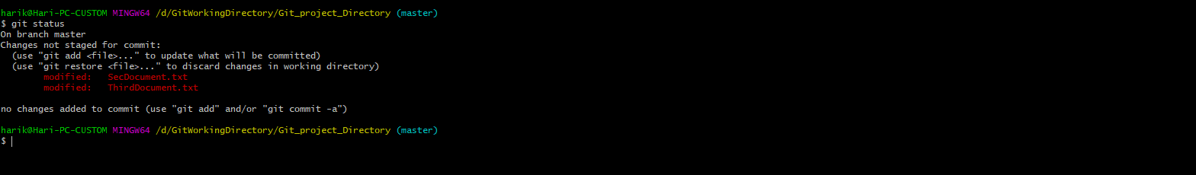

Once you commit, the files/directories will moved to repository Area.

